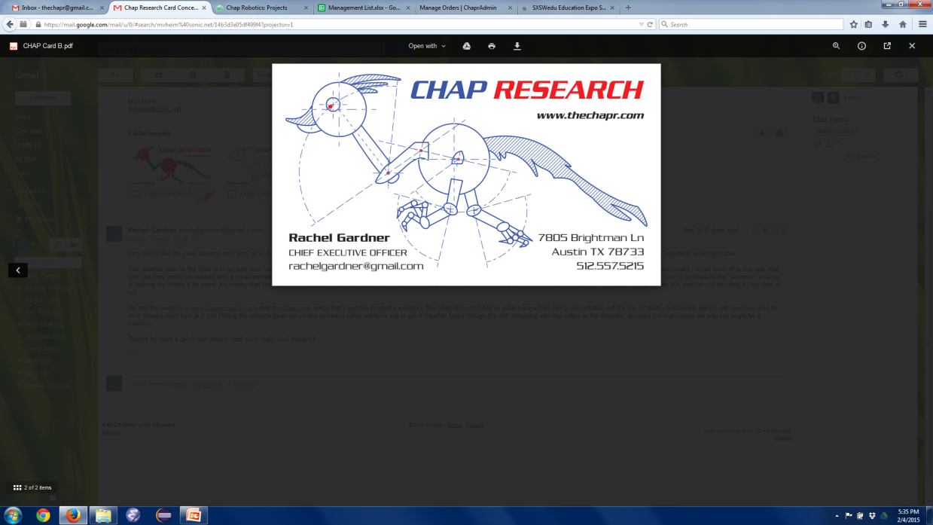

“A framework for innovation”

**What is it?**

Chap Research is an innovation program to give Westlake students the opportunity to learn real world technical and leadership skills not taught in school.

**Why make it?**

* To provide students with an opportunity to experience and participate in research and design, giving them the experience and confidence to succeed in college and career settings.
* To allow students to further explore/develop industry-applicable and entrepreneurial skills not taught in school, including management and patent application
* To create a model to serve as inspiration for similar innovation programs at the high school level
* To link students to mentors in the community to inspire and support their development
* To allow exceptional students to develop portfolios by receiving patents, publication, press coverage and the like for their skill and dedication

**What does it look like?**

* A “framework” of support
  + Finances
    - managed by WESTA (Westlake Eanes Science and Technology Association) a local nonprofit company
  + Facilities
    - a small room at Westlake High School, used for meetings after school
  + Advisory Board
    - industry professionals and college faculty who provide resources and support for the program
  + Board of Directors
    - several individuals (including the student CEO) who oversee management of the program
  + Mentors
    - Experienced students and adults who serve as a knowledge resource
    - Lead skill-building or training seminars
* Several concurrent projects
  + Actively searching for new projects/patents
  + Either (experienced) student or mentor led
    - Teaching entrepreneurial skills
    - Allowing student leadership (building management skills)
  + Documented on website (also to create precedent/continuity within program)
* Industry cooperation
  + Connect projects/problems with industry individuals
* End products/deliverables
  + “Sellable” products (the ChapR)
  + Patents
  + Publications
  + Presentations (ChapX, Champs Conference)

**The Vision**

* Sustainable
  + Students continue with program from beginning to end
  + Still in place for alumni to see when they visit
  + Reliable funding (through grants or otherwise)
* Replicable
  + Other schools/teams create similar programs
* Recognized
  + Westlake High School recognition
  + Produces articles, whitepapers, patents